Factory Pattern

- Factory pattern is one of the most used design patterns in Java
- this pattern provides one of the best ways to create an object.

In Factory pattern, we create object without exposing the creation logic to the client and refer to newly created object using a common interface.

Implementation

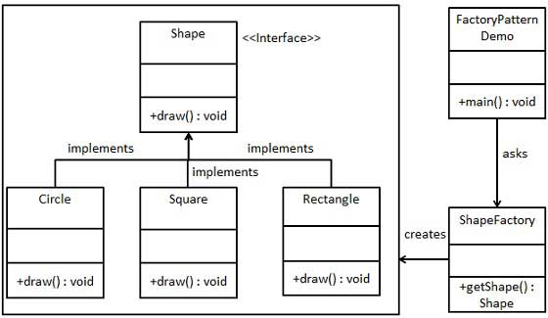

public interface Shape {
void draw();
}

public class Circle implements Shape {

@Override
public void draw() {
System.out.println("Inside Circle::draw() method.");
}
}

public class ShapeFactory {

//use getShape method to get object of type shape
public Shape getShape(String shapeType){
if(shapeType == null){
return null;
}
if(shapeType.equalsIgnoreCase("CIRCLE")){
return new Circle();

} else if(shapeType.equalsIgnoreCase("RECTANGLE")){
return new Rectangle();

} else if(shapeType.equalsIgnoreCase("SQUARE")){
return new Square();
}

return null;
}
}
public class FactoryPatternDemo {

public static void main(String[] args) {
ShapeFactory shapeFactory = new ShapeFactory();

//get an object of Circle and call its draw method.
Shape shape1 = shapeFactory.getShape("CIRCLE");

//call draw method of Circle
shape1.draw();

//get an object of Rectangle and call its draw method.
Shape shape2 = shapeFactory.getShape("RECTANGLE");

//call draw method of Rectangle
shape2.draw();

//get an object of Square and call its draw method.
Shape shape3 = shapeFactory.getShape("SQUARE");

//call draw method of square
shape3.draw();
}
}

Design Pattern - Singleton Pattern

This pattern involves a single class which is responsible to create an object while making sure that only single object gets created.

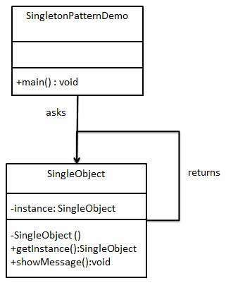

public class SingleObject {

//create an object of SingleObject
private static SingleObject instance = new SingleObject();

//make the constructor private so that this class cannot be
//instantiated
private SingleObject(){}

//Get the only object available
public static SingleObject getInstance(){
return instance;
}

public void showMessage(){
System.out.println("Hello World!");
}
}

public class SingletonPatternDemo {
public static void main(String[] args) {

//illegal construct
//Compile Time Error: The constructor SingleObject() is not visible
//SingleObject object = new SingleObject();

//Get the only object available
SingleObject object = SingleObject.getInstance();

//show the message
object.showMessage();
}
}

Inversion Of Control (IOC) and Dependency Injection

These are the design patterns that are used to remove dependency from the programming code. They make the code easier to test and maintain.

Let's understand this with the following code:

class Employee{
Address address;
Employee(){
address=new Address();
}
}

In such case, there is dependency between the Employee and Address (tight coupling).

In the Inversion of Control scenario, we do this something like this:

class Employee{
Address address;
Employee(Address address){ stateless.
this.address=address;
}
}

IoC Container

The IoC container is responsible to instantiate, configure and assemble the objects. The IoC container gets informations from the XML file and works accordingly. The main tasks performed by IoC container are:

- to instantiate the application class
- to configure the object
- to assemble the dependencies between the objects

There are two types of IoC containers. They are:
- BeanFactory
- ApplicationContext

BeanFactory and the org.springframework.context.ApplicationContext interfaces acts as the IoC container.

1.Bean factory
Bean factory acts has factory method it cretae bean( bean object in interface

The org.springframework.beans.factory.

2.ApplicationContext interface is built on top of the BeanFactory interface.

It adds some extra functionality than BeanFactory such as simple integration with Spring's AOP, message resource handling (for I18N), event propagation, application layer specific context (e.g. WebApplicationContext) for web application. So it is better to use ApplicationContext than BeanFactory.

Dependency Injection in Spring

The Dependency Injection is a design pattern that removes the dependency of the programs.
In such case we provide the information from the external source such as XML file.
It makes our code loosely coupled and easier for testing. In such case we write the code as:

public class Employee {

private int id;
private String name;

public Employee() {
System.out.println("def cons");
}
public Employee(int id)
{
this.id = id;
}
public Employee(String name)
{
this.name = name;stateless.
}
public Employee(int id, String name) {
this.id = id;
this.name = name;
}
void show(){
System.out.println(id+" "+name);
}

}

<bean id="e" class="com.javatpoint.Employee">
<constructor-arg value="10" type="int"></constructor-arg>
</bean>

public class Test {
public static void main(String[] args) {

Resource r=new ClassPathResource("applicationContext.xml");
BeanFactory factory=new XmlBeanFactory(r);

Employee s=(Employee)factory.getBean("e");
s.show();

}
}

Constructor Injection

If there is HAS-A relationship between the classes, we create the instance of dependent object (contained object) first then pass it as an argument of the main class constructor. Here, our scenario is Employee HAS-A Address. The Address class object will be termed as the dependent object. Let's see the Address class first:

package com.javatpoint;

public class Address {
private String city;
private String state;
private String country;

public Address(String city, String state, String country) {
super();
this.city = city;
this.state = state;
this.country = country;
}

public String toString(){
return city+" "+state+" "+country;
}
}

package com.javatpoint;

public class Employee {
private int id;
private String name;
private Address address;//Aggregation

public Employee() {System.out.println("def cons");}

public Employee(int id, String name, Address address) {
super();
this.id = id;
this.name = name;
this.address = address;
}

void show(){
System.out.println(id+" "+name);
System.out.println(address.toString());
}

} ￼
￼
Today interviewer asked

1.how the Dependency Injection is achived in spring with real world example

2.can

<bean id="a1" class="com.javatpoint.Address">
<constructor-arg value="ghaziabad"></constructor-arg>
<constructor-arg value="UP"></constructor-arg>
<constructor-arg value="India"></constructor-arg>
</bean>

<bean id="e" class="com.javatpoint.Employee">
<constructor-arg value="12" type="int"></constructor-arg>
<constructor-arg value="Sonoo"></constructor-arg>
<constructor-arg>
<ref bean="a1"/>
</constructor-arg>
</bean>

Dependency Injection by setter method

We can inject the dependency by setter method also. The <property> subelement of <bean> is used for setter injection. Here we are going to inject
- primitive and String-based values
- Dependent object (contained object)
- Collection values etc.

Injecting primitivMessageServicee and string-based values by setter method
Let's see the simple example to inject primitive and string-based values by setter method. We have created three files here:
- Employee.java
- applicationContext.xml
- Test.java

package com.javatpoint;

public class Employee {
private int id;
private String name;
private String city;

public int getId() {
return id;
}
public void setId(int id) {
this.id = id;
}
public String getName() {
return name;
}
public void setName(String name) {
this.name = name;
}

public String getCity() {
return city;
}
public void setCity(String city) {
this.city = city;
}
void display(){
System.out.println(id+" "+name+" "+city);
}
}

<bean id="obj" class="com.javatpoint.Employee">
<property name="id">
<value>20</value>
</property>
<property name="name">stateless. ￼
￼
Today interviewer asked

1.how the Dependency Injection is achived in spring with real world example

2.can
<value>Arun</value>
</property>
<property name="city">
<value>ghaziabad</value>
</property>
</bean>

public class Test {
public static void main(String[] args) {

Resource r=new ClassPathResource("applicationContext.xml");
BeanFactory factory=new XmlBeanFactory(r);
Employee e=(Employee)factory.getBean("obj");
s.display();

}

Spring - Bean Definition

The objects that form the backbone of your application and that are managed by the Spring IoC container are called beans.

A bean is an object that is instantiated, assembled, and otherwise managed by a Spring IoC container

These beans are created with the configuration metadata that you supply to the container.￼
￼
Today interviewer asked

1.how the Dependency Injection is achived in spring with real world example

2.can

